Want to Take Charge of Your Diabetes in 2022?
Become a Self-Manager!
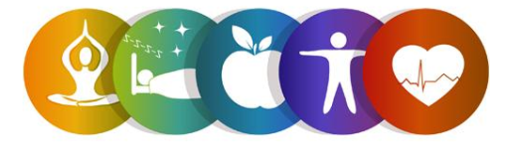
Register for the Common Threads Workshop!
This six-week workshop is part of the Diabetes Self-Management Program and is FREE to adults 60 and older.
In light of COVID-19, this will be offered virtually (Zoom)!

Participants will learn about making a healthy eating plan, managing blood sugar levels, balancing eating, physical activity and medications to prevent problems as well as managing diabetes-specific problems.

To register, contact:
Lauren Jirinec, Health Promotion Specialist
(215)765-9000 ext. 5119
Lauren.Jirinec@pcacares.org

Workshop Details:
This workshop meets on Tuesdays via Zoom. Participants will receive a Self-Management Tool Kit at no cost.
Dates: March 1st, 8th, 15th, 22nd, 29th, and April 5th, 2022
Time: 1:00pm - 3:30pm

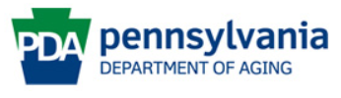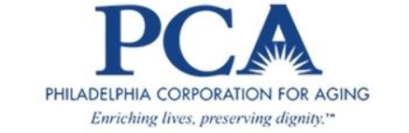
This program is supported by Philadelphia Corporation for Aging through Title IIID funds received from the Pennsylvania Department of Aging. This program was originally developed at Stanford University and is now owned by Self-Management Resource Center, Inc.

