Want to Take Charge of Your Pain in 2022?
Become a Self-Manager!
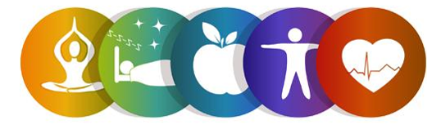
Start the New Year off right and register for the Keep it Moving Workshop!
This abbreviated six-week workshop is a Chronic Pain Self-Management Program and is FREE to adults over 60.
In light of COVID-19, this will be offered via the telephone!
Participants will learn tips and strategies to take charge of their chronic pain. Topics include managing pain, dealing with fatigue, working with health providers, physical activity, addressing poor sleep, problem solving and becoming more involved in everyday activities.

To register, contact:
Lauren Jirinec, Health Promotion Specialist
(215)765-9000 ext. 5119 Lauren.Jirinec@pcacares.org

Workshop Details:
This abbreviated program will be held on Wednesdays via the phone. All participants will be mailed a Self-Management Tool Kit at no cost.
Dates: February 2nd, 9th, 16th, 23rd, March 2nd, and 9th 2022
Time: 1:00pm to 2:00pm

This program is supported by Philadelphia Corporation for Aging through Title IIID funds received from the Pennsylvania Department of Aging. This program was originally developed at Stanford University and is now owned by Self-Management Resource Center, Inc.

