Want to Take Charge of Your Health in 2022?
Become a Self-Manager!
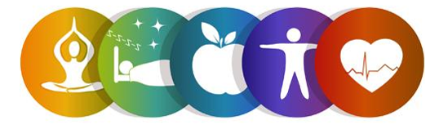
Start the New Year off right and register for the Help Yourself to Health Workshop!
This six-week workshop is a Chronic Disease Self-Management Program and is FREE to adults 60 and older.
In light of COVID-19, this will be offered virtually (Zoom)!
Participants will learn tips and strategies to take charge of their chronic conditions such as heart disease, arthritis and lung disease. Topics include dealing with fatigue, working with health providers, physical activity, addressing poor sleep, problem solving and becoming more involved in everyday activities.

To register, contact:
Lauren Jirinec, Health Promotion Specialist
(215)765-9000 ext. 5119 Lauren.Jirinec@pcacares.org

Workshop Details:
This program will be held on Thursdays via Zoom. All participants will be mailed a Self-Management Tool Kit at no cost.
Dates: February 10th, 17th, 24th, March 3rd, 10th, and 17th 2022
Time: 10:00am to 12:30pm

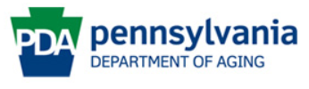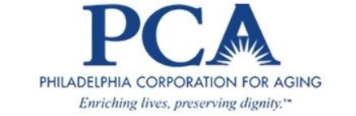
This program is supported by Philadelphia Corporation for Aging through Title IIID funds received from the Pennsylvania Department of Aging. This program was originally developed at Stanford University and is now owned by Self-Management Resource Center, Inc.

