**Want to Take Charge of Your Diabetes?**

***Become a Self-Manager!***

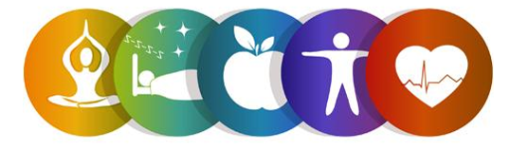

Register for the ***Common Threads*** Workshop!

This six-week workshop is part of the Diabetes Self-Management Program and is FREE to adults 60 and older.

In light of COVID-19, this will be offered *virtually (Zoom)*!

Participants will learn about making a healthy eating plan, managing blood sugar levels, balancing eating, physical activity and medications to prevent problems as well as managing diabetes-specific problems.

**To register, contact:**

**Stephen Merrill, Health Promotion Nurse Supervisor**

**(215)765-9000 ext. 5123** [**Stephen.Merrill@pcacares.org**](mailto:Stephen.Merrill@pcacares.org)

**Workshop Details:**

This six-week workshop meets weekly on Turesdays via Zoom. Participants will receive a Self-Management Tool Kit in the mail at no cost.

**Dates: July 6th, 13th, 20th, 27th, August 3rd, and 10th**

**Time: 10am-12:30pm**

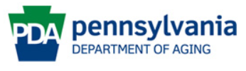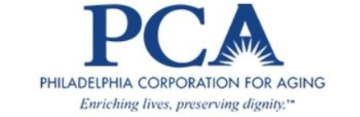

This program is supported by Philadelphia Corporation for Aging through Title IIID funds received from the Pennsylvania Department of Aging.  This program was originally developed at Stanford University and is now owned by Self-Management Resource Center, Inc.