Want to Take Charge of Your Pain?
Become a Self-Manager!
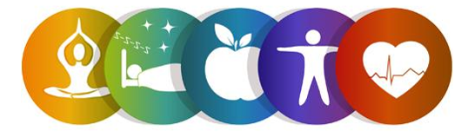
Register for the Keep it Moving Workshop!
This six-week workshop is a Chronic Pain Self-Management Program and is FREE to adults 60 and older.
In light of COVID-19, this will be offered virtually (Zoom)!

Participants will learn tips and strategies to take charge of their chronic pain, deal with problems such as frustration, fatigue, isolation, and poor sleep, and learn how to become more involved in everyday activities.

Workshop Details:
This program will be held on Wednesdays via Zoom. All participants will be mailed a Self-Management Tool Kit at no cost.
Dates: June 23rd, 30th, July 7th, 14th, 21st, and 28th, 2021
Time: 10:00am to 12:30pm

To register, contact:
Lauren Jirinec
Health Promotion Specialist
(215)765-9000 ext. 5119 Lauren.Jirinec@pcacares.org

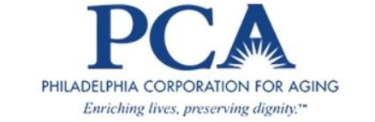
This program is supported by Philadelphia Corporation for Aging through Title IIID funds received from the Pennsylvania Department of Aging. This program was originally developed at Stanford University and is now owned by Self-Management Resource Center, Inc.

